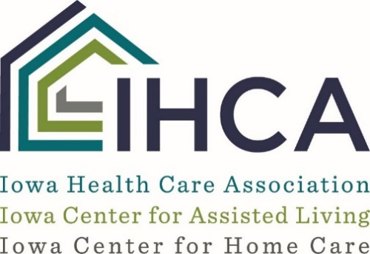

SNFs Providing Nursing Coverage for ALs
Department of Inspections and Appeals (DIA) staff has advised providers that nursing facilities with attached or co-located assisted living programs need to reassess how they provide nursing coverage to an assisted living program that does not have nursing staff present 24 hours a day.
DIA has determined that nursing facilities that have only one nurse on duty may not provide on-site coverage for an assisted living. However, if there is more than one nurse on duty in the NF, a nurse may respond to the assisted living program, if needed.
Any time the nurse spends responding to the AL will need to be deducted from the hours reported by the SNF for PBJ purposes. DIA suggests it is probably most appropriate for the nurse to clock out of the nursing facility before proceeding to the AL. Certified nursing assistants may respond to the AL if there still is adequate coverage in the SNF and PBJ reporting is adjusted accordingly.
The Department cautions that providers must always ensure that the nursing facility has adequate staff before responding to needs in the assisted living program.
Mary Jane Carothers, IHCA VP, Quality Improvement and Clinical Affairs, suggests that members with co-located operations look critically at how they are providing nursing staff to each separate program. In addition, AL programs will need to—at a minimum—review current policies related to incident reporting, pendant response, PRN medication administration, narcotic counting, and administration of CPR in light of this information from the Department.
“DIA has indicated that federal and state regulations require nursing facilities to have a licensed nurse on duty at all times," Mary Jane said. "It is important for members who have relied solely on the SNF for emergency nursing response in their attached AL programs to determine how they will provide coverage for the AL in the future. ”
Dawn Fisk, Administrator, DIA, Health Facilities Division, also provided a statement from DIA on nursing facility sharing nurse coverage with an assisted living.
DIA's statement
At the recent IHCA meetings held around the state, the issue of sharing staff between the certified SNF/NF and an associated AL, RCF, or other facility type was addressed. Providers were informed that the following would apply in situations where staff are "shared":
IF a certified SNF/NF facility can maintain sufficient coverage, it would be acceptable for a nurse or certified nurse aide to "clock out" from the SNF/NF, go assist in the RCF or AL, and then return to the SNF/NF, clocking back in.
While working in the non-certified entity, the nurse or certified nurse aide would NOT be counted for purposes of PBJ nor would they be considered when assessing required nurse coverage or sufficiency of staff during the time they were working in the non-certified entity.
DIA has reached out to CMS again to ensure that this information is accurate and on July 26, 2018, the Kansas City CMS Regional Office reiterated that the information shared above is correct.
Possible solution
For ALs and RCFs in need of RN on-call services, IHCA ICAL has a vendor partner that may offer a solution. The physician telehealth service could possibly be used in member ALs and RCFs to triage and assess in these situations instead of utilizing an SNFs or on-call RN. For more information, contact Cindy Baddeloo, IHCA Sr. VP & COO.

