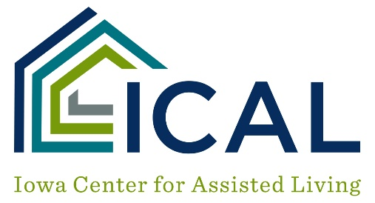

Employee File Review

Employee Name

Date of Hire
Criminal Background Check
Child Abuse Check
Dependent Adult Abuse Check
Dependent Adult Abuse Training
RN Delegation Training
RN ADL Training
RN IADL Training
Dementia Training
- 8 hours within 30 days of hire
- 8 hours annually
- 2 hours annually (for indirect or contracted personnel)
Food Service Sanitation Training
Emergency Procedures
Missing Tenant Training
Door Alarm Training (if applicable)

