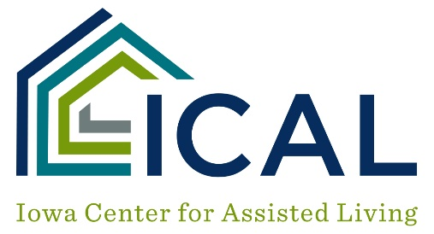

Group Interview Form

LIVING ENVIRONMENT

What do you like about living at the program?

Are housekeeping services completed to your satisfaction?

What improvements are needed?

MEDICAL SERVICES

What happens if someone gets ill or needs help of some sort from staff?

Are nursing services available?

How long does it take for staff to come when called?

CARE PROVIDED BY CONTRACT

Are you getting the services you expected when you signed the occupancy agreement and are the costs what you expected?

STAFF INTERACTION

How would you describe the care you receive?

How do staff treat you?

Do staff know what services they are to provide you?

Are staff trained to provide the services needed?

FOOD

Do you like the food?

Is there a variety of meats, vegetables, and desserts offered?

Do staff serve you appropriately?

Are hot foods served hot?

Are cold foods served cold?

What complaints do you have?

ACTIVITIES

Are there enough activities offered?
What activities would you like to see offered?

SAFETY

Do you feel safe here?

DECISIONS – Autonomy

Who tells you what to do—when to get up – when to go to bed – if and when you can go out – who you can go out with?

GENERAL SATISFACTION

Are you generally satisfied with this program?

Would you recommend this program to a friend?

What could the staff or administration do to make this a better program?

Do you have any other comments or concerns you would like to share with us?

