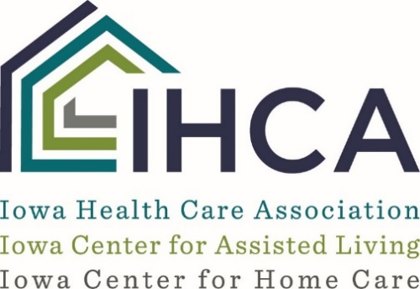

Guidance for Dementia Training Required in Iowa AL’s
Regulations
481—69.30(231C) Dementia-specific education for program personnel.
69.30(1) All personnel employed by or contracting with a dementia-specific program shall receive a minimum of eight hours of dementia-specific education and training within 30 days of either employment or the beginning date of the contract, as applicable.
69.30(2) The dementia-specific education or training shall include, at a minimum, the following:
a. An explanation of Alzheimer’s disease and related disorders;
b. The program’s specialized dementia care philosophy and program;
c. Skills for communicating with persons with dementia;
d. Skills for communicating with family and friends of persons with dementia;
e. An explanation of family issues such as role reversal, grief and loss, guilt, relinquishing the care-giving role, and family dynamics;
f. The importance of planned and spontaneous activities;
g. Skills in providing assistance with instrumental activities of daily living;
h. The importance of the service plan and social history information;
i. Skills in working with challenging tenants;
j. Techniques for simplifying, cueing, and redirecting;
k. Staff support and stress reduction; and IAC 3/16/16
l. Medication management and nonpharmacological interventions.
69.30(3) Dementia-specific continuing education.
a. Except as otherwise provided in this subrule, all personnel employed by or contracting with a dementia-specific program shall receive a minimum of two hours of dementia-specific continuing education annually.
b. Direct-contact personnel employed by or contracting with a dementia-specific program or employed by a contracting agency providing staff to a dementia-specific program shall receive a minimum of eight hours of dementia-specific continuing education annually.
c. Contracted personnel who have no contact with tenants (e.g., persons providing lawn maintenance or snow removal) are not required to receive the two hours of training required in paragraph “a.”
d. The contracting agency may provide the program with documentation of dementia-specific continuing education that meets the requirements of this subrule.
69.30(4) An employee or contractor who provides documentation of completion of a dementia
specific education or training program within the past 12 months shall be exempt from the education and training requirement of subrule 69.30(1).
69.30(5) Dementia-specific training shall include hands-on training and may include any of the following: classroom instruction, Web-based training, and case studies of tenants in the program.

ICAL Recommended Resources for Dementia Specific Training:

CARES Online Dementia Care Training, Certification, and Credentialing – HealthCare Interactive.

AHCA/NCAL support the CARES® online person-centered dementia training program for staff. This program is also endorsed by CMS. CARES® was developed by HealthCare Interactive and is a series of online video-based dementia care training programs featuring real care providers and people with dementia in real settings. Training is accessible 24/7 and can be completed individually, in small groups or in a classroom-style setting. AHCA/NCAL members receive a 10% discount on all orders by entering AHCA10 when registering.

Alzheimer’s Association essentialALZ® Individual Certification
The Alzheimer’s Association essentiALZ® certification program was developed for both professional care providers and family members of a person living with dementia. The essentiALZ exam tests knowledge of evidence-based dementia care practices that are promoted in the nationally recognized Alzheimer’s Association Dementia Care Practice Recommendations and supported by more than 30 leading health and senior care organizations. The Alzheimer’s Association® is the leading voluntary health organization in Alzheimer’s care, support and research. AHCA/NCAL members receive a 10% discount on all orders by entering AHCA10 when registering.
CMS Hand in Hand Dementia Training
The updated “Hand in Hand: A Training Series for Nursing Homes is available free on the Centers for Medicare and Medicaid Website. It is available as a self-paced online training as well as an instructor-led course and may be accessed using the links below. The self-paced training may take approximately 24 hours to complete.
Self-paced online training – “Hand in Hand: A Training Series for Nursing Homes Online”
Downloadable materials for instructor-led training – “Hand in Hand: A Training Series for Nursing Homes Download”
This course has flexibility to meet the “hands-on” requirement of the Iowa AL regulations if needed.
CE Solutions
This IHCA partner offers a suite of dementia online courses including such titles as: “The Basics of Alzheimer’s Disease”, “Activities for Residents with Alzheimer’s Disease”, “Wandering and Elopement in LTC”, “Understanding Dementia”, “Communication”, “Behavior Management and Abuse Training”, “Philosophy of Care, Family and Staff Issues”, “Activities of Daily Living, Medications and Nutrition”, and “Ethical Issues” to help providers meet the Iowa Assisted Living regulations for dementia training.
IHCA ICAL members are offered a discounted rate for these on-line training courses.

