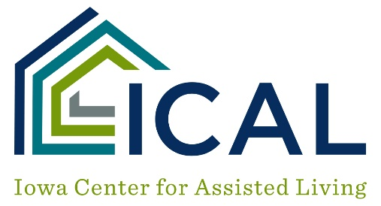

Program Face Sheet/Tenant-Staff List

Topic Comments
Tour of Facility

Staff Interviews

Staff Files Audits

Tenant File Reviews

Tenant Observations

Private Tenant Interviews

Private Family Interviews

Medication Administration Review

Community Meeting with Tenants

Meal Observation

Activities Review

Transportation Review

Food Service Review

Exit Meeting

