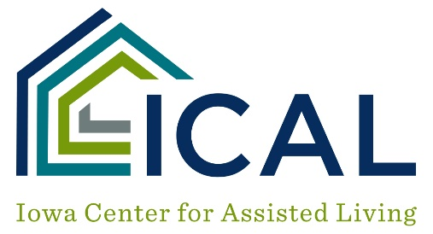

Quality Assurance Checklist

Employee Files
 | Date |  | Date | Date | Date
Hiring Process
Interview Questions/
Reference Checks
Background Check
OIG Check
(EW Bldgs Only)
Dep. Adult Abuse Training
Food Service Training
Emergency Plans Training
Dementia Training
Chauffeur’s or CDL License for those who drive vehicles
ADL Training
Delegations
Physical Plant
Fire Drills
Tornado Drills
Emergency Plans
Door Alarm Checks
Environ Safety Check
Emergency Response Times
Door Obstruction
Cleanliness

Tenant Files
 | Date | Date | Date | Date
Occupancy Agreement
Initial Evaluation
30-day Evaluation
Annual Evaluation
90-day Nurse Reviews
Physician Orders
Review of Parameters
PRN Usage
Antipsychotic Drug Use
Incident Reporting
Clinical Notes
Staff Routines
Timeliness of Med Pass
Use of Needles/Sharps
Skin Issues
General Population with GDS of 4 or above
Documentation for those with GDS of 5 or above
Hospitalizations
Hospice
High Risk Tenants/Those in Transition to Higher Level of Care
Waiver (Level of Care)

