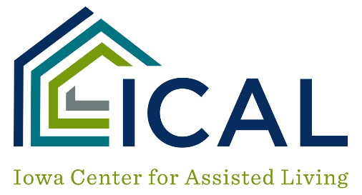

Assisted Living
Sexual Relationships Between Tenants with Cognitive Impairment

POLICY
To address sexual relationships with individuals with cognitive impairment.

PURPOSE
To protect individuals with cognitive impairment who are unable to consent from unwanted sexual relationships.

PROCEDURE
- Cognitive impairment for purposes of this section would be considered those tenants with a GDS score of 5 or above.

- If individuals with cognitive impairment have been identified as engaging in a sexual relationship, the tenants will be assessed by the nurse for the capacity to consent for sexual relationship using the “Verbal Informed Sexual Consent Assessment Tool.”

Other factors to considering in making the decision include:
Are they married?
The length of time they’ve been married or known each other.
Are there negative outcomes when they are together?

- Each tenant's physician will be notified to assist in determining if the tenant has the capacity to consent.

- The legal representative will be notified to be part of the decision-making process regarding the tenant's desire for a sexual relationship.

- If the tenant(s) are found to not have the capacity to consent, the service plan will be updated to reflect interventions to prevent such an encounter.

- The service plan will be updated for those tenants with cognitive impairment who have the capacity to consent. The service plan will inform staff of the sexual relationship and interventions to allow privacy as well as to watch for any negative outcomes.

- The capacity to consent will be reviewed by a nurse every 90 days or with a change in the tenant’s condition.

- A copy of the capacity to consent assessment and other documentation determining capacity to consent will be kept in the tenant's clinical record.

