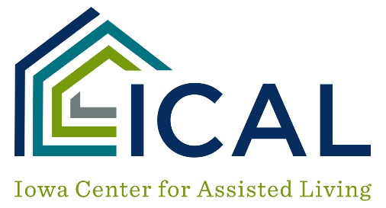

Assisted Living
Sexual Relationship Between Tenants and Program Staff

POLICY
To address sexual relationships between tenants and Assisted Living Program staff.

PURPOSE
To protect tenants from unwanted sexual relationships and exploitation by staff.

PROCEDURE
1. Sexual relationships between tenants and staff are prohibited unless the tenant and staff member are married.

2. It is the program staff duty to report to the Assisted Living Program manager any sexual relationship the staff member has undertaken with a tenant; and report to the same any knowledge of a sexual relationship between other staff members and tenants.

3. Violation of this policy will result in discipline action up to and including termination.

