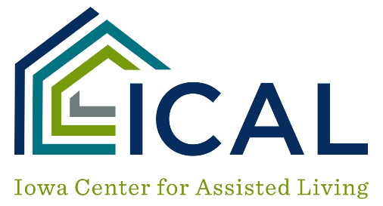
Transportation, Smoking, Activity and Food Service Audit
Program Name: | Date:

TRANSPORTATION
Vehicle Provided/Marketed ___ YES ___ NO
Number of Vehicles Used _________
Passenger Seats Available ____________________________________________
Driver(s) License ___ Chauffeur’s Class D
___ CDL
___ Other
Vehicle Inspection ___ Communication
___ Fire Extinguisher
___ First Aid
___ Triangles

SMOKING NOTIFICATION POSTING
No smoking signs on all exterior doors ___ YES ___ NO
No smoking signs on program vehicles ___ YES ___ NO

ACTIVITIES
Activity Director/Staff ____________________________________________
Hours per week ____________________________________________
Activities for tenants with Dementia ___ YES ___ NO
Complaints re: Activities ___ YES ___ NO

FOOD SERVICE
Dietary Manager ____________________________________________
State Approved Food Safety and Sanitation Training ________________________________________
Menus Approval ____________________________________________
Diets Therapeutic: ___ YES ___ NO
Food License ___ YES ___ NO

