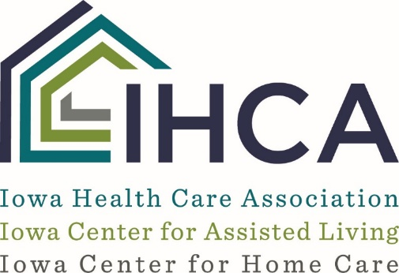

Nursing Facility
Verbal Informed Sexual Consent Assessment Tool

It is important to identify if a resident is cognitively able to give verbal consent to have sexual contact with another resident in the facility. The use of this tool is meant to assist staff in an attempt to determine if the resident is capable of making that decision.

DEFINITION OF SEXUAL CONTACT
What it isn’t: Incidental or accidental contact, handholding, hugging, kissing on cheek or hand.
What it is: Kissing on the mouth, touching of the clothed or unclothed inner thigh, breast, groin, buttocks, anus, pubes or genitals; or a sex act defined as:
- Penetration of the penis into the vagina or anus.
- Contact between the mouth and genitalia or by contact between the genitalia of one person and the genitalia or anus of another person.
- Contact between the finger or hand of one person and the genitalia or anus of another person.
- Ejaculation onto the person of another.
- By use of artificial sexual organs or substitutes contacting with the genitalia or anus of another person.

Before engaging a resident in answering these questions, staff should assure the following:
1. The purpose of this assessment has been explained to the resident,
2. The assessment is completed in a private place, and
3. The resident is informed that his/her answers to the questions will be kept confidential and
used only to assist with providing the best care during his/her stay at the facility.

ASSESS CURRENT SEXUAL KNOWLEDGE:
1. Is there someone NOW that you can talk to about sex? If so, who is that person?

2. Are there sexual things you feel should not be talked about? If so, what do you think some
of these things are?

3. What are some things that two people can do together sexually? (kiss on the mouth, use
their hands to touch each other’s bodies, use their mouths on each other’s bodies, oral, anal and vaginal sex).

ASSESS CURRENT SOCIO-SEXUAL ISSUES:
1. Have you had sex within the past year?

2. Have you had sex with someone when you did not want to?

3. If you had a problem with someone hurting you or forcing you to have sex, what would
you do?

Resident’s Name | MR# | Physician

4. Who do you think is in charge of making sexual decisions in your life?

SCENARIO:
Imagine you are in a private place with a person you have kissed, hugged and touched before. Now this person unzips their pants and asks you to put your hand inside. What do you think this person is asking you to do?

What would you do?

(NOTE: If the resident says they are willing to engage in this activity, ask, what if you didn’t feel like touching this person?)

SAFE SEX QUESTIONS:
1. When a man and a woman have sexual intercourse, the woman can become pregnant. What can you do to prevent pregnancy?

2. Sometimes two people have sexual behaviors, such as oral, anal and vaginal sex and if one person has an infection the other person can get it. What can a couple do to prevent an infection?

LEGAL/ILLEGAL QUESTIONS
(Conditional. Ask these questions to determine if the resident is able to understand illegal sexual activity):
Do you know of any sexual behaviors that are against the law?

Is it ok to watch a ‘porno’ film?

Is it ok to pay money to have sex?

Is it ok for an adult to have sex with a child?

What is a child?

Resident’s Name | MR# | Physician

FOUR PRINCIPLES OF SEXUAL INFORMED CONSENT:
Resident demonstrates:

1. Cognitive ability to make informed decisions by scoring an 8-12 (Moderately Impaired) or 13-15 (Cognitively Intact) on the BIMs Assessment. If the resident’s BIMSs score 7 or below, does the interviewer observe that the resident is capable of giving informed consent by being able to understand content of interview questions? If they have a Guardian and guardianship paperwork has specified orders allowing the guardian to make decisions about the resident’s sexual behavior, the guardian must also be okay with the resident engaging in sexual behavior.

2. An awareness of the nature of sexual acts and the ability to choose to engage or abstain.

______ Yes ______ No

3. An understanding of how to avoid STDs. _____ Yes _____ No.

4. The ability to identify harmful situations and to avoid being exploited.

______ Yes _______ No

Based on the answers to the assessment questions and the resident’s ability to demonstrate the Four Principles of Sexual Informed Consent (above), the resident falls into one of three groups:

1. Resident fulfills requirements of principles and can give verbal informed sexual consent.
This determination is made ONLY if all 4 of the above principles are answered “YES”.

2 Resident cannot give verbal informed sexual consent at the time as he/she has not fulfilled the
requirements of principles as evidence by__________________________________________
___________________________________________________________________________

3. The resident’s ability to provide verbal informed sexual consent is vague and could not be
determined at the time as evidenced by___________________________________________

__________________________________________________________________________

Approach: (1) Re-interview resident on _______________________________ (date).
(2) Educate resident to determine capability to give informed consent. Done on
___________________________________ (date).
(3) Based on these approaches, can the resident give informed consent?
________ Yes _______ No

Resident’s Name | MR# | Physician
4. Resident refused interview? ______ Yes ______ No

______________________________________ ________________________
Staff Signature Date

Resident’s Name | MR# | Physician

