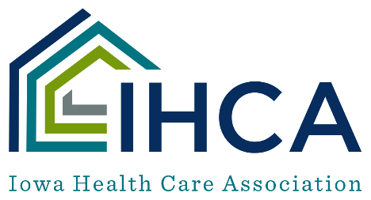

Conventional PPE Strategy Guidelines for Home Health Settings
Due to personal protective equipment (PPE) now being largely available for purchase, agencies are expected to be using conventional capacity PPE strategies.
Guidance when caring for a patient that is asymptomatic or not COVID-19 positive/suspected:
- Communities with minimal to no community transmission: adhere to Standard and Transmission-Based Precautions (TBP) based on anticipated exposures and suspected or confirmed diagnoses. PPE use may include eye protection, N95 or equivalent or higher-level respirator, and other PPE. Universal use of well-fitting facemask for source control continues to be recommended for health care personnel (HCP) if not wearing a respirator mask.
- Communities with moderate to substantial community transmission: follow Standard Precautions (and Transmission-Based Precautions) based on the suspected diagnosis which includes using an N95 respirator or equivalent and face protection for applicable situations with increased risk of pathogen transmission.
Definition of community transmission can be determined by using CMS’s color-coding methodology.
0-5% = Green (No to Minimal Transmission)
5-10% = Yellow (Moderate Transmission)
>10% = Red (Substantial Transmission)

Guidance for caring for a suspected/confirmed COVID-19 positive patient or person who is undergoing testing:
CDC recommends that HCP should care for all patients using N95/respirators, eye protection, gloves, and gowns.
CDC also recommends that patients and their in-home caregiver(s) wear a mask, if possible, while cares are being provided. When cares are not being provided, the caregiver and patient should attempt to isolate from each other. Hand hygiene should be practiced by both the patient and the caregiver a
Notes:
- KN95 masks are to be used in the same fashion as a surgical mask and are not considered respirators. Many KN95s are counterfeit and should not be used.
- The FDA issued a letter to health care professionals outlining their expectation for all respirators to be NIOSH-approved.
- Eye protection can be either goggles or a face shield that covers both the front and side of the HCP face.
- If your agency is experiencing a PPE shortage, documentation of the following should be maintained while adhering to Optimization Strategies:
  - All efforts used to obtain PPE including sources outside of the usual supply network.
  - Notification of state/local public health departments of shortage and request for assistance.
Providers are strongly encouraged to review the CDC’s Interim Infection Prevention and Control Recommendations for Healthcare Personnel During the Coronavirus Disease 2019 (COVID-19) Pandemic and other additional guidance.

Masks Defined
 | Disposable/Procedure Mask | Surgical Mask | N95 Respirator
Description | A mask that covers the user's nose and mouth and may or may not meet fluid barrier or filtration efficiency levels. Face masks may be used by the general public and health care personnel as source control in accordance with CDC recommendations. | A mask that covers the user's nose and mouth and provides a physical barrier to fluids and particulate materials. The mask meets certain fluid barrier protection standards and Class I or Class II flammability tests. While surgical masks may be effective in blocking splashes and large-particle droplets, they do not provide complete protection from germs and other contaminants because of the loose fit between the surface of the mask and your face. | N95s and surgical N95s, filter at least 95 percent of airborne particles. They are PPE that tightly fit the face and provide certain filtration efficiency levels to help reduce wearer exposure to pathogenic airborne particles in a health care setting. They provide a higher level of protection against viruses and bacteria when properly fit-tested.
Can it be used for Source Control? | Yes | Yes | Yes
Appropriate Use | - Routine tasks and patient care | - Routine tasks and patient care  - Transmission-based precautions | - During all aerosol-generating procedures (nebulizers, high flow O2, etc.)  - When caring for patients with suspected or known COVID-19
Authorization Required | None | FDA-approved | NIOSH certified
When to dispose | After each patient encounter | After each patient encounter | After each patient encounter
Fit testing required | No | No | Yes

