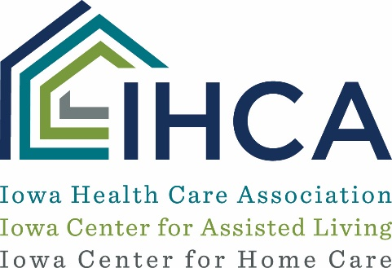

COMMUNICATIONS RESOURCE:
Messaging for Family Members Regarding Staffing Shortages
How to Use this Resource:
The messaging below can be used to assist with communicating with family members about the use of staffing agencies to address staffing shortages. It can be modified for your organization’s particular situation and used to draft letters, newsletter articles or other communications to family members. It is recommended to print this letter on your organization’s own letterhead.

[Date]
Dear [Family Member Name]:
While the COVID-19 pandemic has created unprecedented challenges across the health care system, I wanted to take a moment to assure you that the care of your loved one remains our top priority. At [Organization Name], we are grateful for the opportunity to provide [insert any specific examples here of the types of care your organization provides] for your loved one. Thank you for entrusting their care with us.
We are committed to providing great quality care for all we serve. One of the many ways we are doing that includes bringing on and training additional staff to provide your loved one with even more personal care, so you may see a few new faces around, which may also include those who work for staffing agencies. [Insert any specifics on the new individuals as appropriate. For example, Mary and Susan joined our team last week.] We are excited to have these new staff members on board, and I think you will be too.
We also wanted to be sure to note that if you are interested in volunteering or working at the center, please contact us at [Phone Number]. There are a variety of positions you may find of interest in a long-term care center that don’t necessarily require a nursing degree, such as activities, dietary and housekeeping services. And if you are interested in pursing a nursing program, we’d be happy to visit with you further about that as well.
If you have any questions at any time, please don’t hesitate to contact us at [insert phone number]

Sincerely,
[Name, Title]

