Determining your county’s level of community transmission
Facilities should be checking their county’s level of community transmission to determine the frequency of routine testing and use of eye protection. Facilities are reminded that their method to determine testing frequency and use of PPE should be outlined in their organization’s policy or procedure and applied consistently. As the CDC’s COVID Tracker is updated daily and changes can occur, facilities are encouraged to choose a designated time each week to check the data source for that week’s determination. (For example, every Monday before noon)
Below are the steps to determine your county’s level of community transmission.
Step 1:
Navigate to the CDC COVID Data Tracker using this web address: https://covid.cdc.gov/covid-data-tracker/#county-view
Step 2:
Choose the state and county in which the facility is located.
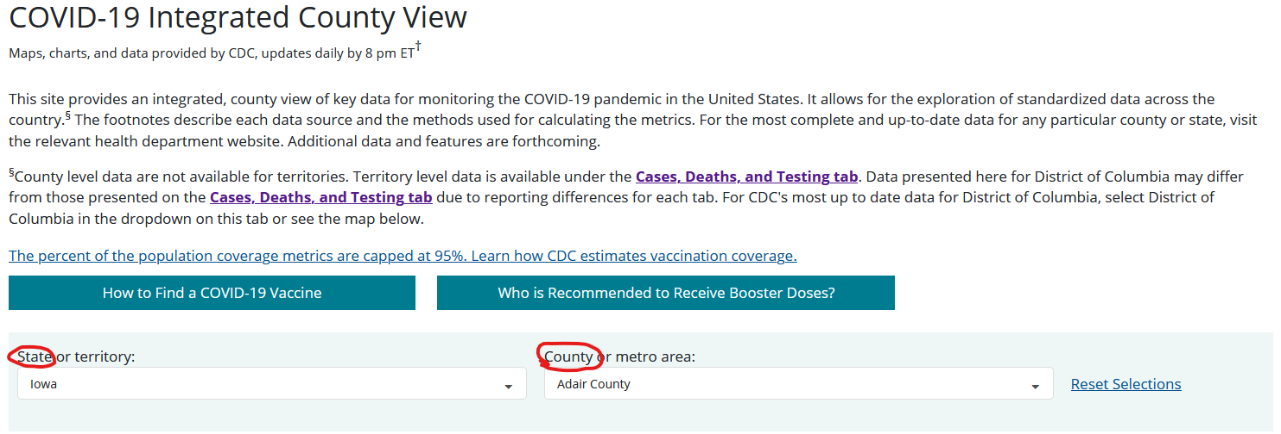
Step 3:
Choose “Community Transmission” from the Data Type dropdown box. The Map Metric will change automatically once the Data Type selection is made.
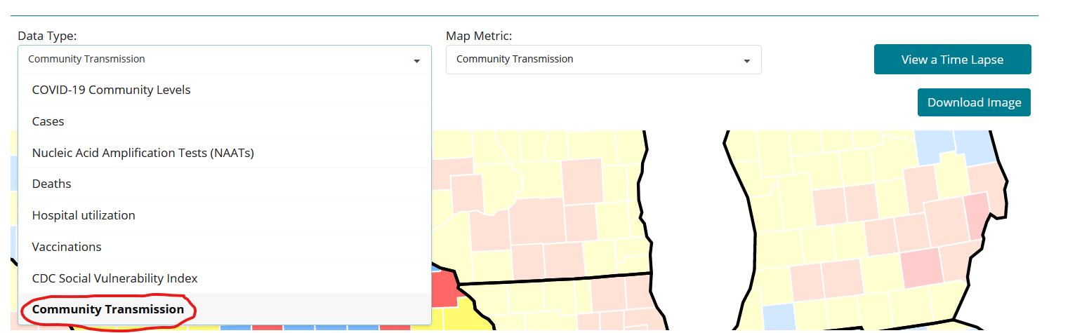

Step 4:
Locate the Case Rate per 100,000 population.
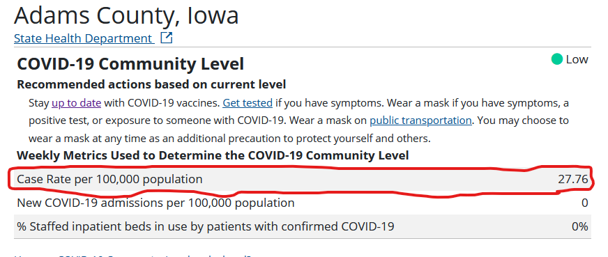
Step 5:
Compare the Case Rate per 100K to the table below to determine the category in which the facility is included. For the example given above, the county would fall into the Moderate category, as 27.76 falls between 10 and 49.99.
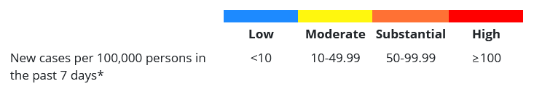
Step 6:
Document the findings each week.

*Note: The Department of Inspections and Appeals is aware of the challenges presented by the ever-changing and inconsistent nature of the CDC’s data source. They encourage facilities to address their approach and maintain documentation of how the determination of county level of community transmission was attained to share with surveyors upon request. So long as a good faith effort is demonstrated to make an educated decision, negative regulatory outcomes should not occur.

