2023 Discounted Sleeping Room Rates

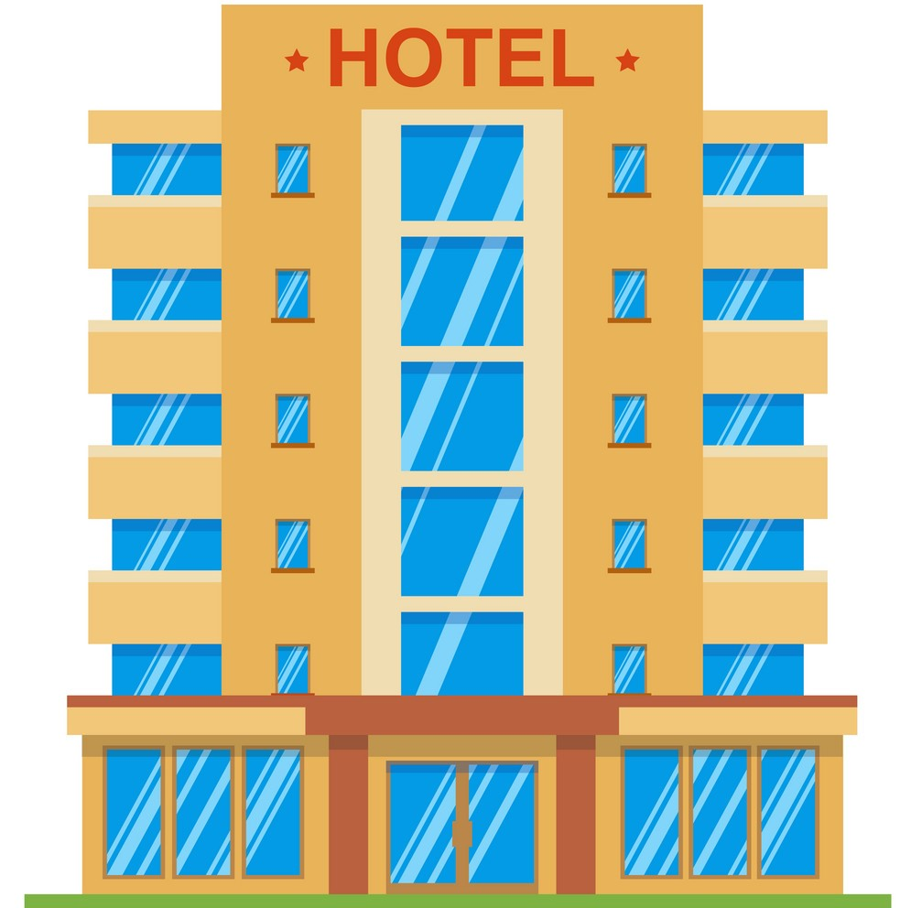
Need a hotel room to attend an event at Iowa Health Care Association?
IHCA has negotiated special discounted sleeping room rates for its members at several West Des Moines area hotels. You can utilize these discounts whenever you need to stay in the Des Moines area. These rates are valid through December 2023. Please note that the room rate may not be available during special events and blackout dates and are based on availability at the time the reservation is made.
To receive the discounted rates, request the “Iowa Health Care Association” room rate when making your reservation.

StayBridge Suites Wildwood Lodge
6905 Lake Dr. 11431 Forest Ave.
(Interstate 80, exit 121) (Interstate 35/80, exit 124)
West Des Moines, IA Clive, IA
(515) 223-0000 (515) 222-9876
Room rate: $99 plus tax – King Studio Suite Room rate: $92 plus tax – King room
$139 plus tax – Double Queen Suite $99 plus tax – Double - 2 Queen room
WoodSpring Suites (New Hotel) Sleep Inn (New Hotel)
7255 Lake Dr. 2885 Grand Prairie Parkway
(Interstate 80, exit 121) (Interstate 80, exit 118)
West Des Moines, IA Waukee, IA
(515) 705-7644 (515) 987-6691

Room rate: $55.00 plus tax – Single Room rate: $85 plus tax – King Room
$65.00 plus tax - Double $115 plus tax – Two Queen Room
Hampton Inn Courtyard by Marriott
7060 Lake Dr. 1520 NW 114th ST.
(Interstate 80, exit 121) (Interstate 35/80, exit 124)
West Des Moines, IA Clive, IA
(515) 223-4700 (515) 225-1222
Room rate: $89 plus tax – Single/Double Room rate: $94 plus tax – Single/Double
To reserve a room, visit www.marriott.com/dsmch.
Enter Z36 in the “corporate/promotional code” field.
Comfort Inn & Suites (New Hotel) Marriott – West Des Moines
1625 Jordan Creek Parkway Interstate 80 and Jordan Creek Parkway
(Interstate 80, exit 121) (Interstate 80, exit 121)
West Des Moines, IA West Des Moines, IA
(515) 440-3679 (515) 267-1500

Room rate: $89.99 Single or $94.99 Double Room rate: $129 plus tax – Single/Double
Iowa Health Care Association
1775 90th St.
West Des Moines, IA 50266
(800) 422-3106
All hotels are located within 3 miles
of the IHCA Office and Education Center
